**Whether budget airline can survive in Hong Kong**

Charis Hui

Christy Chung

Christie Leung

Phoebe Lo

Budget airline provides comparatively low-cost tickets to travelers. They mainly stationed at secondary airports to provide short trips and transit flights. To minimize cost and survive, they may collect extra fees for meals or services. They may not offer numbered seat allocation too.

Budget airline cannot survive in Hong Kong due to five reasons:

1. The ticket fee is too low which is difficult to compensate the operating cost.
2. Low price elasticity of demand of traditional airline and low demand for budget airline

3. There are diseconomies of scale.

4. The structure of Hong Kong airline market is monopoly.

5. There is close substitute.

Firstly, though the operating cost of budget airline is not too high, the ticket fee is too low to compensate the cost. Hence, budget airline cannot survive in Hong Kong. The operating cost for an airline is extremely high; for example, it costs Cathay Pacific US$3.286 billion to buy additional 10 A350-1000 aircraft and US$1.087 billion to convert the existing order of 16 A350-900 aircraft into A350-1000 aircraft with Airbus S.A.S. on 8th August 2012. As the cost is higher than the sales revenue, budget airline cannot make a profit or may even experience a loss so that it does not have enough capital to be put back into the business and pay for the daily operating cost. Therefore, one of the factors of production, capital cannot be fulfilled due to the bad debt so budget airline cannot survive in Hong Kong.

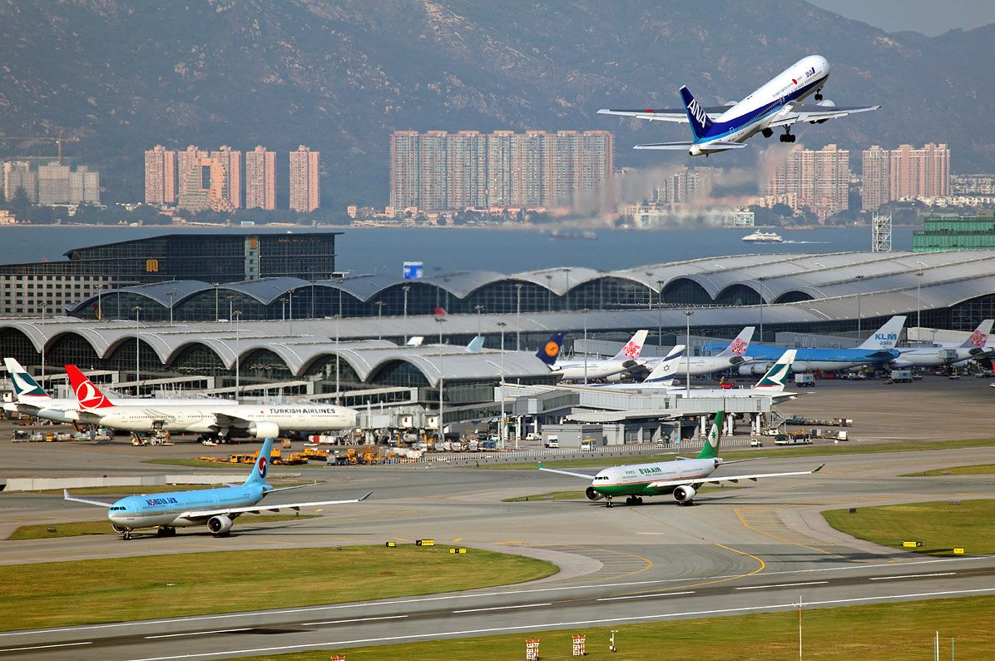

In addition, the price elasticity of demand of traditional airlines is inelastic. It is because there is no close substitute for traditional airline. Most Hong Kong people love enjoying life and often go to trip for pleasure during holidays. They may rather choose exclusive flight with flight services rather than budget airline even though they need to pay a higher price so budget airline cannot substitute traditional airline. Therefore, the demand for budget airline is low. Statistics shows that the only existing current budget airline company in Hong Kong – Hong Kong Express, now with the operation over only 10 countries, its demand in Hong Kong is only 5%. The major reason is they enjoy the higher standard services provided by the traditional airlines. Hence, budget airline cannot survive in Hong Kong because the demand for it is low.

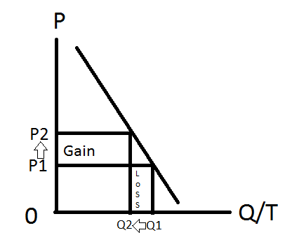

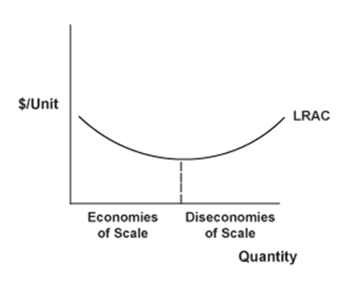Moreover, there may be diseconomies of scale in the long run, which will lead to an increase in the average cost as the budget airline expands. The fixed costs of the airline industry are extremely high, such as the parking fee, ground handing and the purchase of aircraft, and there is a need to expand the company by increasing their routes. When the budget airline becomes too large, it will be difficult and expensive to control and monitor. The complex organizational structure of a large firm will delay decisions making and becomes too bureaucratic. Also, it may be hard for the large budget airline to get bank loans or the interest rate is high because they have already borrowed a lot of loans and the bank will think the risk of further borrowing is high. Thus, the average cost will start to increase. When the cost is too high and the profit cannot compensate, it is hard for the budget airline to continue running.

Furthermore, the Hong Kong airline market structure is monopoly which makes it even more difficult for budget airline to survive. Cathay Pacific holds 50% of the market share. As a typical monopolist, Cathay Pacific may have exclusive dealing with plane providers to eliminate competition. In that case, budget airlines cannot purchase their own airplanes. They will have to depend on borrowing from other airlines. This will increase the operational cost for budget airlines. Cathay Pacific can enjoy economies of scale which budget airline cannot. Cathay Pacific has built a HK$5.9 billion cargo terminal in Hong Kong International Airport. As the fixed cost is large, when there are more cargoes coming through the terminal, the average total cost will decrease. Compared to budget airlines which have not accumulated enough capital and money reserve, large airlines companies who are monopoly can endure this period of having lower revenue or even suffer a loss. Thus, budget airlines may have the risk of being forced out of the market.



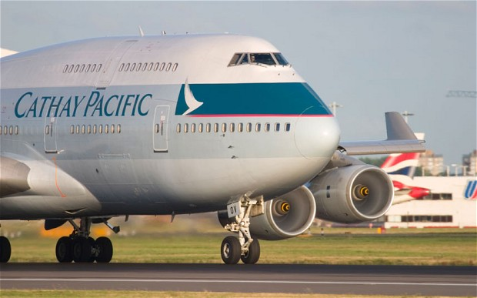

However, some people argued that budget airline can survive in Hong Kong because Hong Kong has a geographical competitive edge. Hong Kong is the Southern gateway to China and is part of the Eurasian aviation so that budget airline is very suitable for connecting other parts of the world to mainland China using Hong Kong as a linkage. Therefore, it is very profitable for budget airline and it can survive. Nevertheless, with the development of the Hong Kong section of the Guangzhou – Shenzhen – Hong Kong Express Rail Link, it will connect Hong Kong to the 16,000km National High-speed Railway Network. It is a close substitute of the budget airline as both of them connect other parts of the world to mainland China so it will threaten the survival of the budget airline. Express Rail Link has advantage over budget airline. The ticket of it is cheaper than budget airline as the operating cost is cheaper and the quality is similar. Hence, people will switch to take the Express Rail Link and budget airline will lose business and cannot survive in Hong Kong.

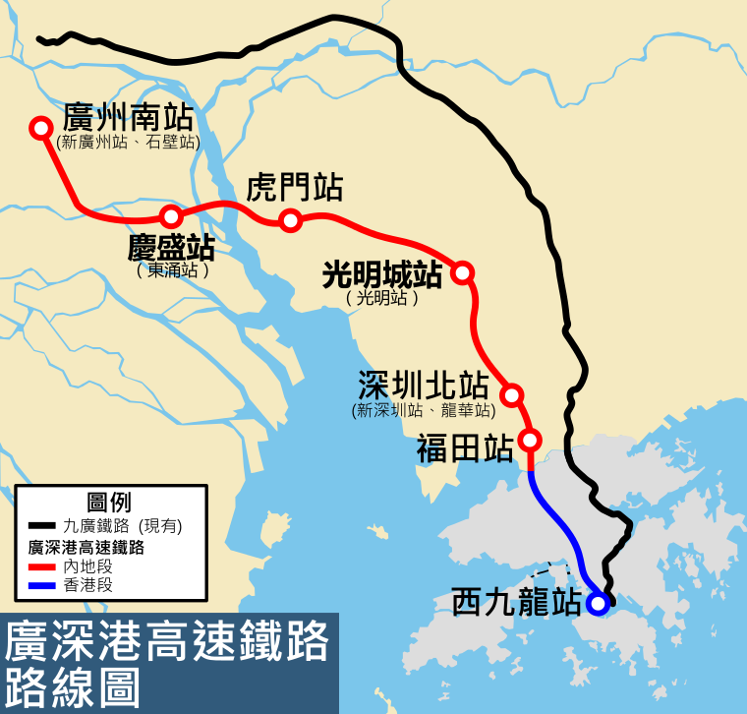

Base on the map, it demonstrates Hong Kong will be part of the China High Speed Railway which the station will be operating in 2017.

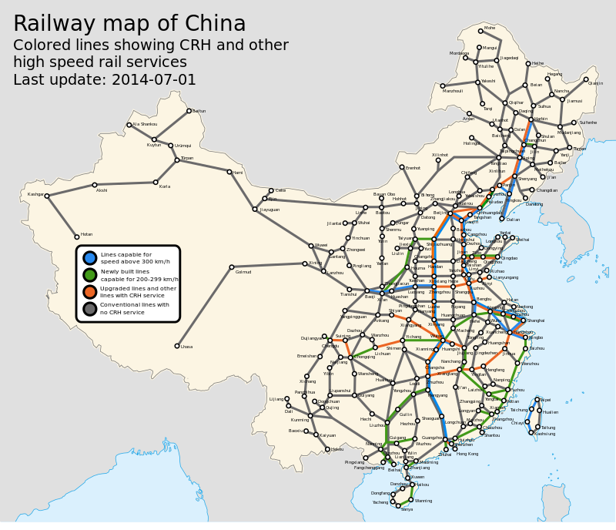

The map shows the China’s railway system has extended over 60% of the country and mostly the eastern part.

The failure of budget airline, Oasis Hong Kong Airlines is a prove that budget airline cannot survive in Hong Kong. It established in 2005 but liquidated and closed in 2008. It failed mainly due to 4 reasons. Firstly, it missed the chance of borrowing airplanes to use and forced to pay high price to purchase them which increased the operating cost. Secondly, the oil price was extremely high at that time which was around US$100 per gallon. This had added burden to the operating cost. Thirdly, Oasis could not employ local Hong Kong workers due to the intense competition. Therefore, it could only employ the more costly foreign workers and this further increased the operating costs. Lastly, it could not find any investors so they lacked capital to support their business after all. Therefore, this example proves that budget airlines cannot survive in Hong Kong due to the lack of capital and high uncompensated operating cost.

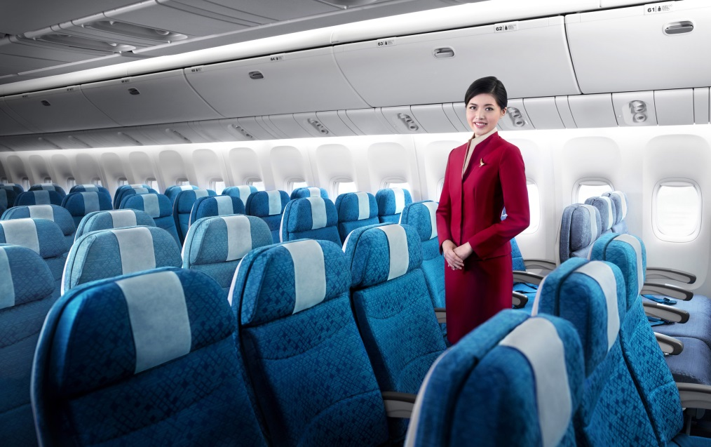In conclusion, budget airlines cannot survive in Hong Kong because there is close substitutes and high entry barrier. Also, the operating cost cannot be covered. The demand for a budget airline in Hong Kong is low too. With Oasis serving a failed example of budget airline in Hong Kong, for budget airlines to survive in Hong Kong is highly impossible.

**References:**  
Aviation industry in Hong Kong <http://www.edb.gov.hk/attachment/en/curriculum-development/kla/pshe/references-and-resources/economics/Aviation%20Economics_Eng_(file%201).pdf>  
Oasis Hong Kong Airlines   
<http://en.wikipedia.org/wiki/Oasis_Hong_Kong_Airlines>  
Express Rail Link  
http://www.expressraillink.hk/en/home/