Notes on Chapter 9
Books of Original Entry

9.1 Books of original entry

When the firm is very small, all the double entry accounts can be kept in one book, which we would call the ledger. As the firm grows it would be impossible just to use one book, as the large number of pages needed for a lot of transactions would mean that the book would be too big to handle.

The answer to this problem is for us to use more books, (i.e., division of ledger). They are divided into Sales Ledger, Purchases Ledger and General Ledger. As General Ledger contains all kinds of accounts except debtors and creditors account, they may become overloaded. As a result, we further separate them into books, each responsible for a particular kind of transactions. In fact, it is the nature of the transactions that decides which book the transaction is entered into. Sales will be entered in one book, purchases in another book, cash in another and so on. As all transactions will be recorded in these books first, they are called Books of Original Entry.

9.2 Types of Book of Original Entry

- Sales Journal (Day Book)
- Purchases Journal (Day Book)
- Returns Inwards Journal
- Returns Outwards Journal
- Cash Book
- General Journal

1. Sales journal and ledger

- Sold goods on credit to Bessie and Shirley for $400 and $800 respectively.
- Cash sales amounted to $500

Bessie
$

Shirley
$

Sales
$

Bank
$

From the above sales account, we can see that sales account record both cash sales and credit sales. Since sales account and all other assets, liabilities, expenses and revenue accounts are recorded in general ledger, the general ledger may be overloaded if only the sales account has so many items to be recorded. Therefore, a book called Sales Journal is used to record all the credit transactions - credit sales only. By using the same example as above, the procedures and entries are as follows:

The credit sale cycle

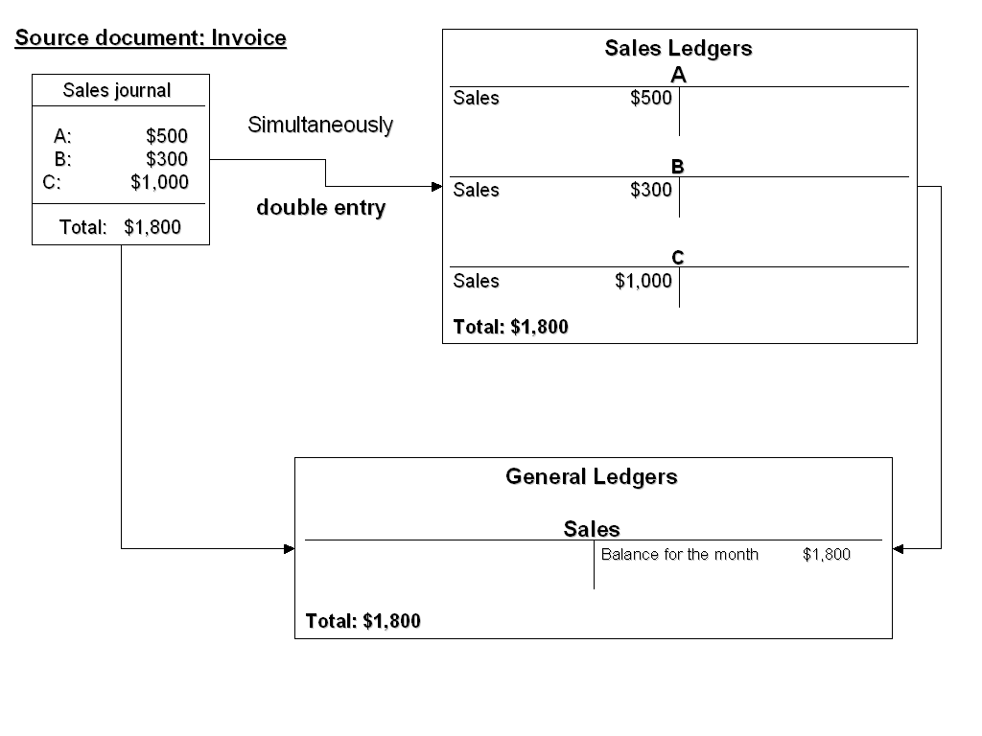

Sales Invoice

If sales are made on credit, the selling firm will send a document to the buyer showing details and prices of the goods sold. This document is known as an invoice.

Trade discount

Trade discount is a special discount given by a seller to a buyer who buys in bulk.

* Only the net price (after the deduction of trade discount) should be entered to sales journal and debtor’s account. No entry for trade discount should be made in the double entry records.

2. Purchases journal and ledgers

- Bought goods on credit from Vera and Jaime for $100 and $200 respectively.
- Cash purchase amounted to $500

Vera
 | $ |  | $
 |  | Purchases | 100

Jaime
 |  |  | $
 |  | Purchases | 200

Purchases
 | $ |  | $
Vera | 100
Jaime | 200
Cash / Bank | 500

Bank
 |  |  | $
 |  | Purchases | 500

Purchases account records all the cash purchases and credit purchases. Similar to sales account, purchases account is also recorded in general ledger. To avoid overloading the general ledger, purchases journal is used to record all credit purchases. The procedures and entries are as follows:

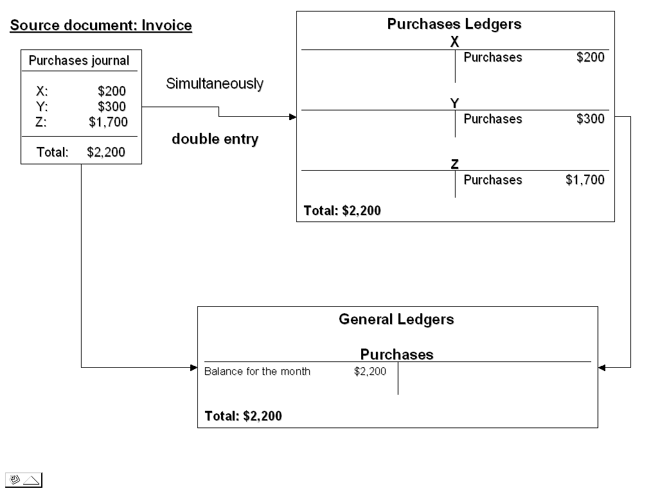

3. Returns inwards journal

If goods are returned, the seller will send a document called a credit note to the buyer to show the amount of allowance given by the seller for the returned goods. The reason why the document is called credit note is because the customer’s account will be credited in the seller’s book. Credit note is usually printed in red.

- Goods returned by Candy and Chloe for $70 and $130 respectively.

Candy
 | $ |  | $
Balance b/d | 770

Chloe
 | $ |  | $
Balance b/d | 630

Returns inwards
 | $ |  | $
Returns inwards journal records all the returned goods from customers. The procedures and entries are as follows:

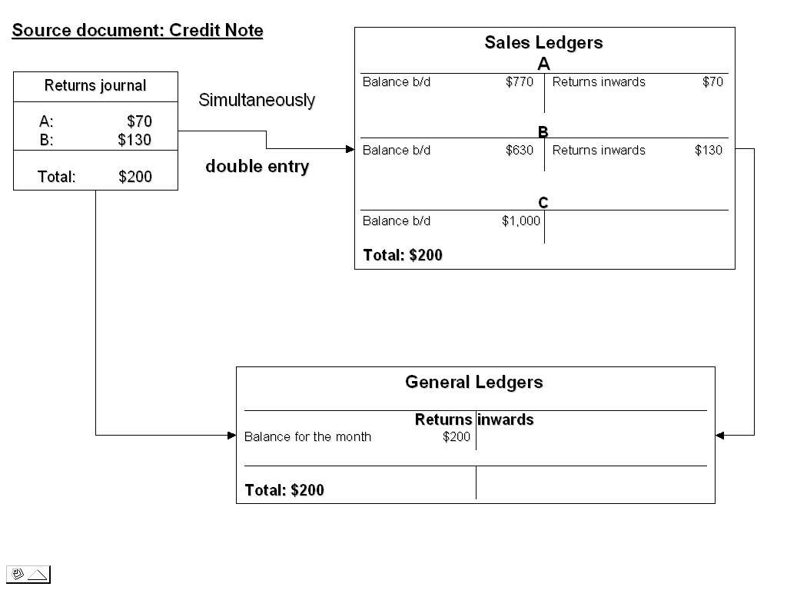

Note:

If goods are sold to buyer with trade discount allowed by seller, the amount of the returned goods should also be deducted by the trade discount first before entering into returns inwards journal.

4. Returns outwards journal

When a firm returned goods to its supplier, instead of posting the returns to returns outwards account individually, returns outwards journal is used to record all the returns first. At the end of each month, add up the total in Returns Outwards Journal and post it to the credit side of Returns Outwards account in General Ledger.

- Goods returned to Mandy and Janice for $400 and $300 respectively.

Mandy
 | $ |  | $
Returns outwards | 400 | Balance b/d | 1,800

Janice
 | $ |  | $
Returns outwards | 300 | Balance b/d | 750

Returns outwards
 | $ |  | $
 |  | Mandy | 400
 |  | Janice | 300

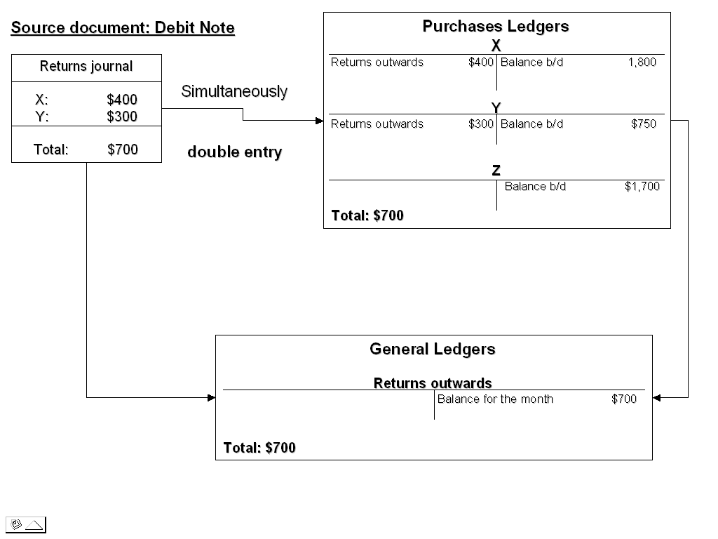
Note:

The returned goods to supplier should be recorded at net amount in returns outwards journal if the goods are bought with trade discount given by supplier originally.

9.3 Exercises

BK_ENTRY01
Feb 2 Sold goods to Mr. Wong on credit $500 with 10% trade discount.

Feb 4 We bought goods on credit from Mr. Leung $800 with 5% trade discount.

Feb 10 We returned goods $200 (list price) to Mr Leung.

Feb 12 Mr. Wong returned $100 (list price) goods to us.

Feb 15 Mr. Wong settled his account with 5% cash discount.

Feb 20 We paid Mr. Leung with 10% cash discount

BK_ENTRY02

The following balances were outstanding by debtors on 30 April 2004:
W Wang $840; T Tung $360; K Ming $2,080

The following transactions took place during May 2004:
May 1 Sold goods on credit to T Tung for $160 less trade discount 25%
- W Wang paid us the amount owing by cheque less 5% cash discount
- Sold goods on credit to K Ming $800 less 30% trade discount
- Sold goods on credit to K Mok $80. No trade discount allowed.
- K Ming paid us the amount owing by him on 30 April 2004 by cheuqe, less 5% cash discount.
- K Mok paid us one-half of the amount owing by him in cash. No cash discount was allowed.

You are required to show for the month of May 2004:
- Sales journal written up.
- Sales ledger written up, and all the accounts balanced off.
- The sales account and the discounts allowed account in the general ledger.

BK_ENTRY03

On 30 May 2002, the balance in the purchases ledger: K Wong $580, and the balance in the sales ledger, T San $300. Also, the balances in cash and bank accounts were $5,300 and $4,500 respectively.

The following are transactions for June 2002:

Jun 1 Bought goods on credit $3,000 with 1% trade discount from N Ng. If we
can settle the debts before 15 June, 3% cash discount will be given.

Jun 2 Sold goods on credit $800 with 2% trade discount to W Chow. 1% cash
discount will be given if he can settle the debts within 15 days.

Jun 5 Sold goods on credit $500 with 1% trade discount to T San.

Jun 10 We paid N Ng the amount owed to him by cash.

Jun 12 T San returned goods with list price $100 to us.

Jun 14 W Chow repaid the debts owed to us by cheque.

Jun 20 We sent K Wong a cheque for $550 in full settlement of his account.

Jun 21 T San settled his account by cash.

BK_ENTRY04

The following data has been extracted from the books of Mr Fung:

Sept 1 Cash in hand: $6,200, Bank overdraft: $280

Sept 2 Bought goods for $6,000 on credit from ABC Ltd less 10% trade discount.

Sept 5 Sold goods for cash $3,000.

Sept 6 Sold goods for $8,000 on credit to XYZ Ltd less 20% trade discount. We
gave them 10% cash discount if they can settle his account within 10 days.

Sept 10 Bought goods from Mr Tong by cheque where the list price of goods was
$3,000 and 5% trade discount was allowed.

Sept 13 Faulty goods returned to ABC Ltd, the list price was $2,000.

Sept 17 Sold goods to Peter for $2,800 on credit less 20% trade discount.

Sept 20 Received a cheque from XYZ Ltd in the settlement of the invoice dated
September 6.

Sept 21 Bought machinery on credit from Better Ltd $10,000.

Sept 24 Paid ABC Ltd by cheque deducting a 10% cash discount.

Sept 25 Notified by the bank that the cheque from XYZ Ltd was dishonoured. A
bank charges $50 was incurred.

Required

- Prepare purchases journal, sales journal and returns outwards journal and all the relevant accounts.

- Prepare the 3-column cash book and discounts accounts.

