Notes on Chapters 2

The Classification of Accounts and the Ledgers

2.1 An account
- A record of transactions of similar nature.
- Examples of accounts include a sales account, an asset account, a debtor account, etc.

  - Types of accounts

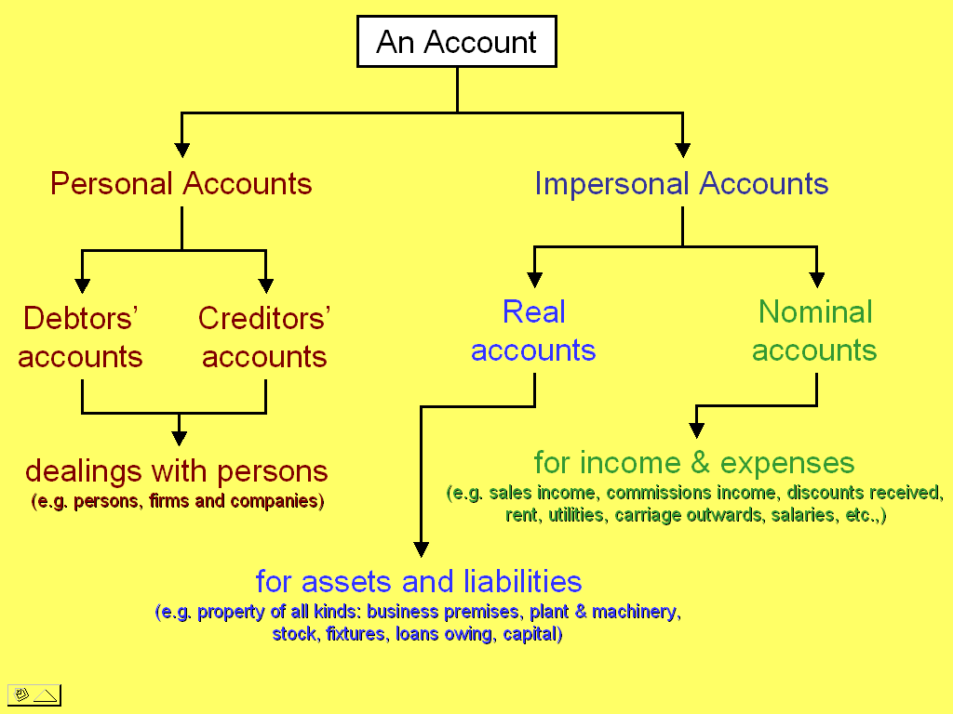

New Terms:

Personal accounts:
- Accounts that record dealings with persons, including firms and companies.
- They are subdivided into debtors accounts and creditors accounts.

Impersonal accounts:
- Accounts other than those dealing with persons.
- They are subdivided into nominal accounts and real accounts.

Nominal accounts:
- Accounts that record income and gains and accounts that record expenses and losses.

Real accounts:
- Accounts that record assets and liabilities.

  - The ledger

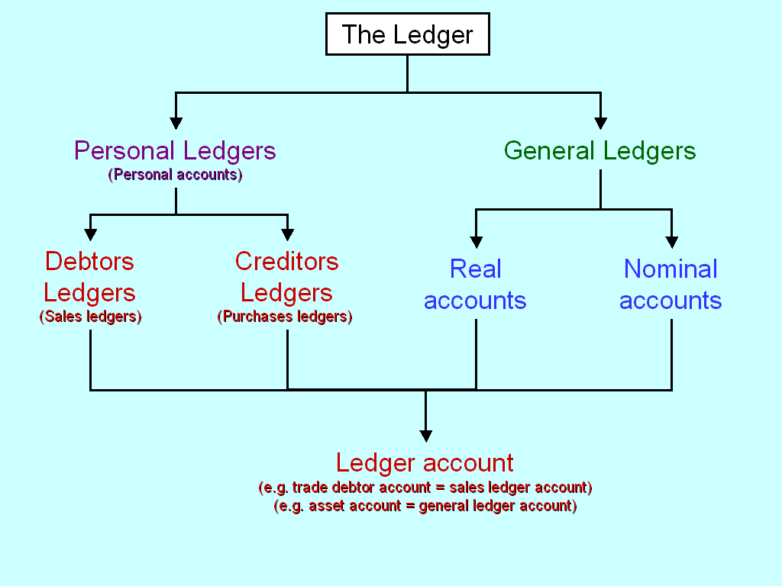

New Terms:

Personal ledger:
- A collection of personal accounts. It comprises of debtors accounts and creditors accounts.
- It can be subdivided into debtors ledger and creditors ledger.

General ledger:
- A collection of all other accounts.
- It includes all assets and liabilities accounts, as well as income accounts and expenses accounts.

Ledger account:
- A record of business transactions of similar nature belonging to a certain ledger.

Format of a ledger account

Account No. … Name of Account …
Dr. Cr.
Date | Particulars | Folio | Amount | Date | Particulars | Folio | Amount

  - Chart of accounts
- A list of the names of the ledger accounts properly codified / identified by account numbers is called the chart of accounts.

