Notes on Chapters 3 – Part II

Double Entry System and The Accounting Equation

3.1 The Accounting Equation

The whole of accounting is based upon a very simple idea. This is called the accounting equation.

It can be explained by saying that if a firm is to be set up and start trading, then it needs resources. Let us assume that in the first place it is the owner of the business who has supplied all of the resources. This can then be shown as:

Resources in the business = Resources supplied by the owner

In accounting, terms are used to describe things. The total amount of resources supplied to a business by the owner is called capital. The actual resources (owned by a business) that are then in the business are called assets. This means that the accounting equation above, when the owner has supplied all of the resources, can be shown as:

Assets = Capital

Usually, someone other than the owner has supplied some of the assets. Liabilities are the name given to the amounts owing to these people for these assets. The equation has now changed to:
Assets = Capital + Liabilities

It is a fact the totals of each side will always equal one another, and that this will always be true no matter how many transactions there may be.

- Assets
- resources owned by the business.
- examples include land and buildings, plants and machinery and furniture and equipment.
- debtors (debts owed by customers), money in the bank account and cash at hand.

- Liabilities
- debts or obligations owed by the business to outside parties.
- money owing for goods supplied to the firm and for expenses.
- examples are trade creditors, loans owing and accounts payable.

- Capital / Equity
- total amount of resources supplied to a business by its owner.
- the owner’s equity or net worth.

3.2 The Balance Sheet

The accounting equation is shown in a statement called the balance sheet. The balance sheet is simply a statement showing the assets of a business and the claims against those assets. This is not the first step to record data, but should be the first place to consider accounting. We will show how the balance sheet is affected by different trading activities.

- The introduction of capital
- On 1 May 2002, John Wong opened a bank and started in business. He put $100,000 into a bank account as his investment in the business.

John Wong's
Balance Sheet as at 1 May 2002
Assets | $ |  | $
Cash at bank | 100,000 | Capital | 100,000
 | 100,000 |  | 100,000

- The purchase of an asset by cheque
- On 3 May 2002, John bought a motor van of $50,000 by cheque.

John Wong's
Balance Sheet as at 3 May 2002
Assets | $ |  | $
Motor Van | 50,000 | Capital | 100,000
Cash at bank | 50,000
 | 100,000 |  | 100,000

Effects:
  - Cash at bank has been reduced.
  - A new asset , i.e. motor van, has appeared.

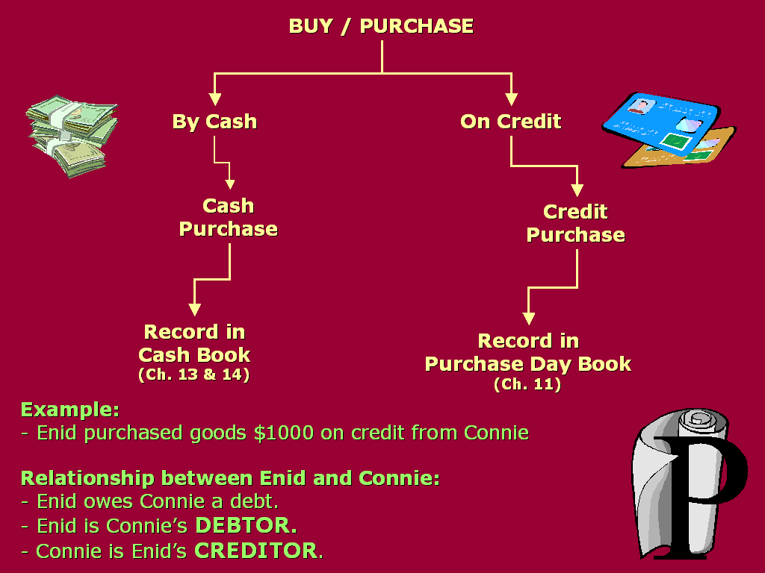

- The purchase of goods and the incurring of a liability
- On 10 May 2002, John decided to buy some goods for $12,000 on credit from Kelvin Johnson.

John Wong's
Balance Sheet as at 10 May 2002
Assets | $ | Capital & Liabilities | $
Motor Van | 50,000 | Capital | 100,000
Stock of goods | 12,000 | Creditors | 12,000
Cash at bank | 50,000
 | 112,000 |  | 112,000

New Terms:

Creditor:
- A person to whom money is owed for goods or services.

Stock / Inventory:
- Goods which are bought for the intention for resale.

Effects:

  - A new asset – stock has created.
  - A new liability – creditor has appeared.

- Sale of an asset on credit
- On 15 May 2002, goods, which had cost $2,500 were sold to Connie Ma on credit.

John Wong's
Balance Sheet as at 15 May 2002
Assets | $ | Capital & Liabilities | $
Motor Van | 50,000 | Capital | 100,000
Stock of goods | 9,500 | Creditor [Kelvin Johnson] | 12,000
Debtor [Connie Ma] | 2,500
Cash at bank | 50,000
 | 112,000 |  | 112,000

New Terms:

On Credit:
- On credit means the transaction is NOT on the ‘cash on delivery’ basis. The payment is deferred and the customer is promised to pay later.

Debtor:
- A person who owes money to a business for goods or services supplied to him.

Effects:

  - The asset – the stock is decreased.
  - A new asset – debtor has been created.
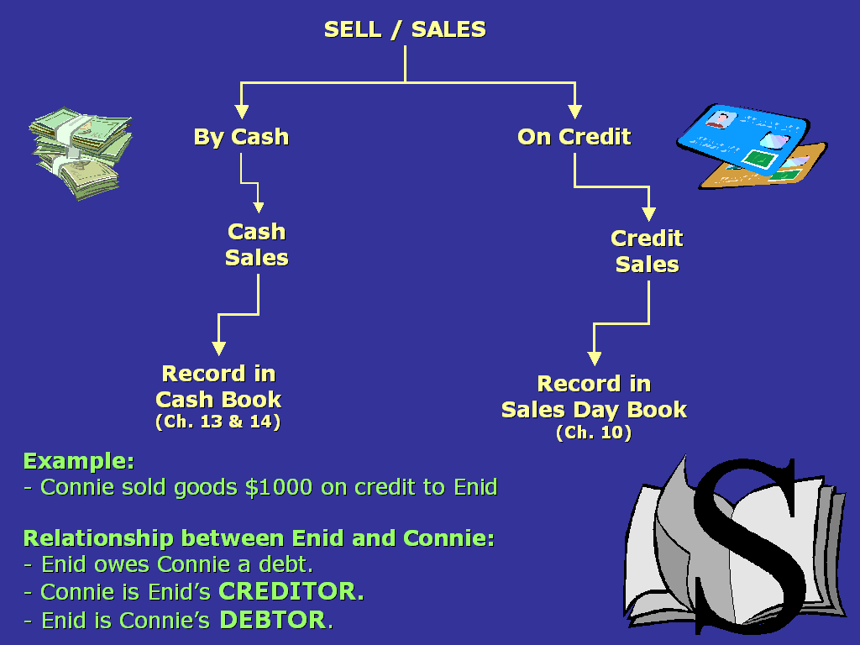

- The payment of a liability
- On 20 May 2002, the business paid a cheque owing to Kelvin Johnson of $7,000.

John Wong's
Balance Sheet as at 20 May 2002
Assets | $ | Capital & Liabilities | $
Motor Van | 50,000 | Capital | 100,000
Stock of goods | 9,500 | Creditor [Kelvin Johnson] | 5,000
Debtor [Connie Ma] | 2,500
Cash at bank | 43,000
 | 105,000 |  | 105,000

Effects:

  - The asset – the bank is reduced.
  - The liability – creditor is also reduced.

- The collection of an asset
- On 31 May 2002, Connie Ma, who owed John $2,500 made a partial payment of $1,500 by cheque.

John Wong's
Balance Sheet as at 20 May 2002
Assets | $ | Capital & Liabilities | $
Motor Van | 50,000 | Capital | 100,000
Stock of goods | 9,500 | Creditor [Kelvin Johnson] | 5,000
Debtor [Connie Ma] | 1,000
Cash at bank | 44,500
 | 105,000 |  | 105,000

Effects:

  - The asset – the debtor is reduced.
  - Another asset – bank is increased.

3.3 Summary

It can be seen that every transaction has affected two items. Sometimes it has changed two assets by reducing one and increasing another. In some cases, both items affected, e.g. asset and liability, has been increased or decreased.

Transactions | Items affected | Effects ( + ) / ( - ) upon:
Transactions | Items affected | Assets | Liabilities | Capital
Buy goods on credit (from Peter) | Stock on goods  Creditors | + | +
Sold goods by cheque | Stock of goods  Bank | -  +
Sold goods on credit (to Stephen) | Stocks of goods  Debtors | -  +
Paid creditor by cheque | Bank  Creditors | - | -
Owner (John) pays more capital into the bank | Bank  Capital | + |  | +
Debtors paid the business for the amount owing | Bank  Debtors | +  -
Bought machinery on credit (from ABC Company) | Machinery  Creditors | + | +
Owner (John) takes money out of the business bank account for his own use | Bank  Capital | - |  | -
Owner (John) pays creditor from private money outside the firm | Creditors  Capital |  | - | +

2.4 Exercise

Transactions | Items affected | Effects ( + ) / ( - ) upon:
Transactions | Items affected | Assets | Liabilities | Capital
(1) Started an engineering business putting $5,000 into a business | Bank  Capital | + |  | +
(2) Purchase of stock on credit from Unique Machines for $1,350 | Stock of goods  Creditors [Unique Machines] | + | +
(3) Withdrew $150 from the bank and placed them in the cash box | Bank  Cash in hand | -  +
(4) Sold some stocks for $150 on credit to Tai Wah Company Ltd. | Stock of goods  Debtors [Tai Wah Co. Ltd] | -  +
(5) Returned some of the stock, valued at $200 to Unique Machines | Stock of goods  Creditors | - | -
(6) Tai Wah pays the firm the amount owing, $150 | Bank  Debtors | +  -
(7) Paid the amount of $300 to Unique Machines by cheque | Bank  Creditors | - | -

(1)
XXX
Balance Sheet as at YYY
Assets | $ | Capital & Liabilities | $
Cash at bank | 5,000.00 | Capital | 5,000.00
 | 5,000.00 |  | 5,000.00

(2)
XXX
Balance Sheet as at YYY
Assets | $ | Capital & Liabilities | $
Stock of goods | 1,350.00 | Capital | 5,000.00
Cash at bank | 5,000.00 | Creditor [Unique Machine] | 1,350.00
 | 6,350.00 |  | 6,350.00

(3)
XXX
Balance Sheet as at YYY
Assets | $ | Capital & Liabilities | $
Stock of goods | 1,350.00 | Capital | 5,000.00
Cash at bank | 4,850.00 | Creditor [Unique Machine] | 1,350.00
Cash in hand | 150.00
 | 6,350.00 |  | 6,350.00

(4)
XXX
Balance Sheet as at YYY
Assets | $ | Capital & Liabilities | $
Stock of goods | 1,200.00 | Capital | 5,000.00
Debtor [Tai Wah] | 150.00 | Creditor [Unique Machine] | 1,350.00
Cash at bank | 4,850.00
Cash in hand | 150.00
 | 6,350.00 |  | 6,350.00

(5)
XXX
Balance Sheet as at YYY
Assets | $ | Capital & Liabilities | $
Stock of goods | 1,000.00 | Capital | 5,000.00
Debtor [Tai Wah] | 150.00 | Creditor [Unique Machine] | 1,150.00
Cash at bank | 4,850.00
Cash in hand | 150.00
 | 6,150.00 |  | 6,150.00

(6)
XXX
Balance Sheet as at YYY
Assets | $ | Capital & Liabilities | $
Stock of goods | 1,000.00 | Capital | 5,000.00
Debtor [Tai Wah] | 0.00 | Creditor [Unique Machine] | 1,150.00
Cash at bank | 5,000.00
Cash in hand | 150.00
 | 6,150.00 |  | 6,150.00

(7)
XXX
Balance Sheet as at YYY
Assets | $ | Capital & Liabilities | $
Stock of goods | 1,000.00 | Capital | 5,000.00
Cash at bank | 4,700.00 | Creditor [Unique Machine] | 850.00
Cash in hand | 150.00
 | 5,850.00 |  | 5,850.00

