Notes on Chapters 3 – Part II

Double Entry System and The Accounting Equation

3.3 Summary

It can be seen that every transaction has affected two items. Sometimes it has changed two assets by reducing one and increasing another. In some cases, both items are affected, e.g. asset and liability, have increased or decreased.

Transactions | Items affected | Effects ( + ) / ( - ) upon:
Transactions | Items affected | Assets | Liabilities | Capital
Buy goods on credit (from Peter) | Stock on goods  Creditors | + | +
Purchase goods by cheque | Stock of goods  Bank | +  -
Sold goods on credit (to Stephen) | Stocks of goods  Debtors | -  +
Paid creditor by cheque | Bank  Creditors | - | -
Owner (John) pays more capital into the bank | Bank  Capital | + |  | +
Debtors paid the business for the amount owing (by cheque) | Bank  Debtors | +  -
Bought machinery on credit (from ABC Company) | Machinery  Creditors | + | +
Owner (John) takes money out of the business bank account for his own use | Bank  Capital | - |  | -
Owner (John) pays creditor from private money outside the firm | Creditors  Capital |  | - | +

3.4 Exercise A

Transactions | Items affected | Effects ( + ) / ( - ) upon:
Transactions | Items affected | Assets | Liabilities | Capital
(1) Started an engineering business putting $5,000 into a business | Bank  Capital | + |  | +
(2) Purchase of stock on credit from Unique Machines for $1,350 | Stock of goods  Creditors [Unique Machines] | + | +
(3) Withdrew $150 from the bank and placed them in the cash box | Bank  Cash in hand | -  +
(4) Sold some stocks for $150 on credit to Tai Wah Company Ltd. | Stock of goods  Debtors [Tai Wah Co. Ltd] | -  +
(5) Returned some of the stock, valued at $200 to Unique Machines | Stock of goods  Creditors | - | -
(6) Tai Wah pays the firm the amount owing, $150 | Bank  Debtors | +  -
(7) Paid the amount of $300 to Unique Machines by cheque | Bank  Creditors | - | -

(1)
XXX
Balance Sheet as at YYY
Assets | $ | Capital & Liabilities | $
Cash at bank | 5,000.00 | Capital | 5,000.00
 | 5,000.00 |  | 5,000.00

(2)
XXX
Balance Sheet as at YYY
Assets | $ | Capital & Liabilities | $
Stock of goods | 1,350.00 | Capital | 5,000.00
Cash at bank | 5,000.00 | Creditor [Unique Machine] | 1,350.00
 | 6,350.00 |  | 6,350.00

(3)
XXX
Balance Sheet as at YYY
Assets | $ | Capital & Liabilities | $
Stock of goods | 1,350.00 | Capital | 5,000.00
Cash at bank | 4,850.00 | Creditor [Unique Machine] | 1,350.00
Cash in hand | 150.00
 | 6,350.00 |  | 6,350.00

(4)
XXX
Balance Sheet as at YYY
Assets | $ | Capital & Liabilities | $
Stock of goods | 1,200.00 | Capital | 5,000.00
Debtor [Tai Wah] | 150.00 | Creditor [Unique Machine] | 1,350.00
Cash at bank | 4,850.00
Cash in hand | 150.00
 | 6,350.00 |  | 6,350.00
(5)
XXX
Balance Sheet as at YYY
Assets | $ | Capital & Liabilities | $
Stock of goods | 1,000.00 | Capital | 5,000.00
Debtor [Tai Wah] | 150.00 | Creditor [Unique Machine] | 1,150.00
Cash at bank | 4,850.00
Cash in hand | 150.00
 | 6,150.00 |  | 6,150.00
(6)
XXX
Balance Sheet as at YYY
Assets | $ | Capital & Liabilities | $
Stock of goods | 1,000.00 | Capital | 5,000.00
Debtor [Tai Wah] | 0.00 | Creditor [Unique Machine] | 1,150.00
Cash at bank | 5,000.00
Cash in hand | 150.00
 | 6,150.00 |  | 6,150.00
(7)
XXX
Balance Sheet as at YYY
Assets | $ | Capital & Liabilities | $
Stock of goods | 1,000.00 | Capital | 5,000.00
Cash at bank | 4,700.00 | Creditor [Unique Machine] | 850.00
Cash in hand | 150.00
 | 5,850.00 |  | 5,850.00

3.5 Exercise B

Here is the balance sheet of C. Ko at the close of business on 31 May 2003:

C. Ko
Balance Sheet as at 31 May 2003
Assets | $ | Capital & Liabilities | $
Fixtures | 8,700.00 | Capital | 41,500.00
Motor vehicles | 18,500.00 | Creditors | 2,500.00
Stock of goods | 6,300.00
Debtors | 2,400.00
Cash at bank | 8,100.00
 | 44,000.00 |  | 44,000.00

The following transactions occurred on 1 June 2003:
  - Bought extra fixtures on credit for $200.
  - Bought an extra motor van paying by cheque immediately for $6,500.
  - Debtors paid us by cheque for $900.
  - Paid to creditors by cheque for $700.
  - C. Ko brought in extra capital, paid into bank for $2000.
  - Purchase of stock by cheque for $300.
  - Purchase of stock on credit for $800.
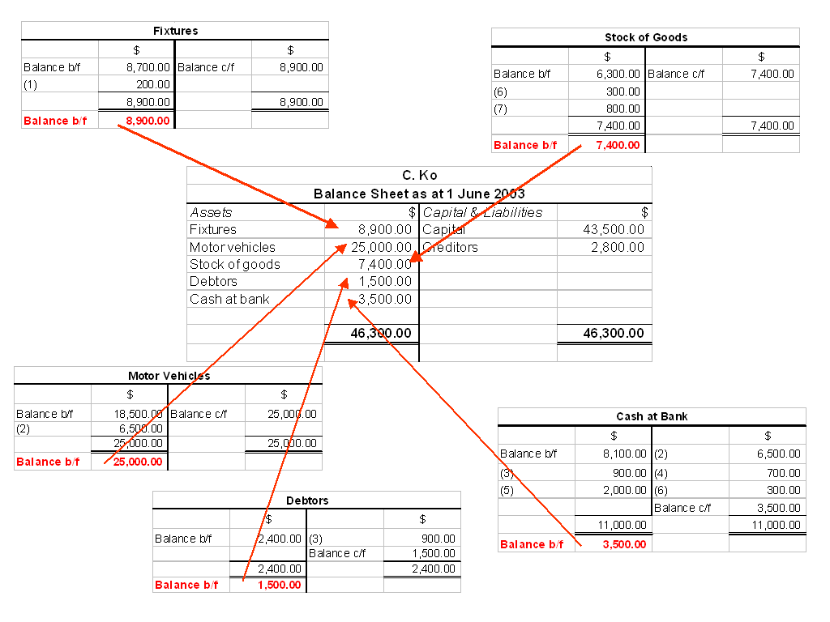
The closing amount of each asset account on the Balance Sheet comes from the individual ledger (closing) balance of each ledger account.

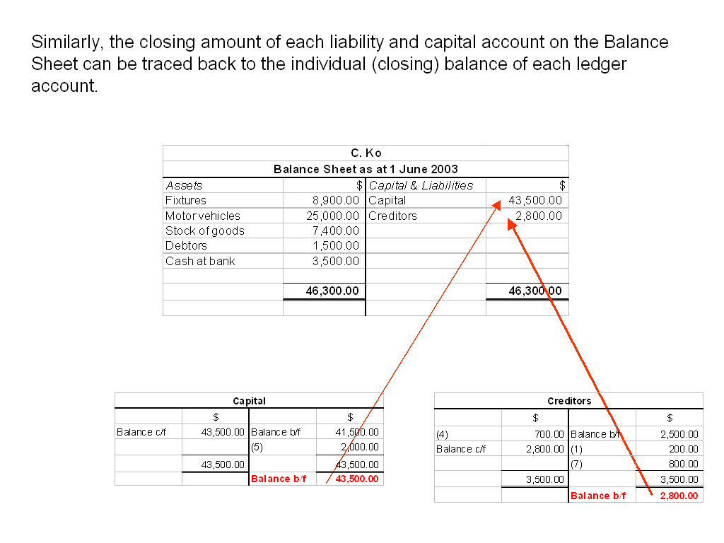

3.6 The Double Entry System

We have seen that every transaction affects two items. If we have to show the effect of every transaction when we are doing our bookkeeping, we will have to show the effect of a transaction on each of the two items.

In 2.4 Exercise A, we drew up a new balance sheet after each transaction. You can do this easily if you have only a few transactions per day. But if there are hundreds of transactions each day, it will become impossible for you to draw up hundreds of different balance sheets.

Instead of constantly drawing up amended balance sheets after each transaction, what we have is the double entry system. The basis for this system is that the transactions which have occurred are entered in a set of ‘accounts’. An account is a place in our books where all the information referring to a particular asset, liability or capital, is entered. Thus there will be an account for motor vans, where all transactions concerning motor vans will be entered. This will be extended so that every asset, every liability and capital will have its own account, for transactions in that item.

New Terms:

Double entry bookkeeping:
- A system by which each transaction is entered twice.

Account:
- Part of double entry records, containing details of transactions for a specific item.

3.7 The Accounts for Double Entry

Each account can be shown on a separate page. The double entry system divides each page into TWO halves. The left-hand side of each page is called the debit while the right-hand side is called the credit side. The title of each account is written across the top of the account at the centre as shown below.

Title of account
Date | Particulars | $ | Date | Particulars | $
This is the DEBIT (Dr) side
This is the CREDIT (Cr) side

3.8 Double Entry Rules

Since transactions were to increase or decrease assets, liabilities or capital, the double entry rules for accounts are:

T- account
⬆ | Assets | ⬇ | Assets
⬇ | Liabilities | ⬆ | Liabilities
⬇ | Capital | ⬆ | Capital

Let us look at the accounting equation:

 | Assets = | Liabilities | + Capital
To increase each item | Debit | Credit | Credit
To decrease each item | Credit | Debit | Debit

Steps for making correct double entry:

- Decide which TWO items are affected.
- Classify which category that each of the TWO items belongs to. (i.e. assets, liabilities or capital)
- Decide whether they are increasing or decreasing in their own category.
- Apply the rule and complete the double entry.

Example 1:

On 31 May 2003, John paid cash $2,000.00 to buy machinery.

- Which 2 items are affected?

  - CASH and (b) MACHINERY

- What are their categories?

  - CASH = assets / liabilities / capital

  - MACHINERY = assets / liabilities / capital

- Are they increasing or decreasing in their respective category?

  - CASH is a kind of ASSET which is increasing / decreasing.

  - MACHINERY is a kind of ASSET which is increasing / decreasing.

- Apply the rule and complete the double entry.

Cash
Date | Particulars | $ | Date | Particulars | $
 |  |  | May 31 | Machinery | 2000

Machinery
Date | Particulars | $ | Date | Particulars | $
May 31 | Cash | 2000

3.9 Exercise A

Complete the table below and write down the transactions in account form. The first one has been done for you as an example.

 | Date | Transactions | Effect | Action
(A) | 2004  May 1 | Started an engineering business putting $1000 into a business bank account. | Increases asset of bank  Increases capital of owner | Dr: Bank account  Cr: Capital account
(B) | May 3 | Bought machinery on credit from Unique Machines $275. | Increases asset of machinery  Increases liability to Unique Machines | Dr: Machinery a/c  Cr: Unique Machines a/c
(C) | May 4 | Withdrew $200 cash from the bank and placed it in the cash box. | Increases asset of cash  Decreases asset of bank | Dr: Cash a/c  Cr: Bank a/c
(D) | May 7 | Bought a motor van, paying in cash $180. | Increases asset of motor van  Decreases asset of cash | Dr: Motor Van a/c  Cr: Cash a/c
(E) | May 10 | Sold some of the machinery for $15 on credit to S. Au. | Increases asset of money owing by S. Au  Decreases asset of machinery | Dr: S. Au’s a/c  Cr: Machinery a/c
(F) | May 21 | Returned some of the machinery, value $27, to Unique Machines. | Decreases liability to Unique Machines  Decreases asset of machinery | Dr: Unique Machines a/c  Cr: Machinery a/c
(G) | May 28 | S. Au paid the firm the amount owing, $15, by cheque. | Increases asset of bank  Decreases asset of money owing by S. Au | Dr: Bank a/c  Cr: S. Au’s a/c
(H) | May 30 | Bought another motor van, paying by cheque $420. | Increases asset of motor van  Decreases asset of bank | Dr: Motor Van a/c  Cr: Bank a/c
(I) | May 31 | Paid the amount of $248 to Unique Machines by cheque. | Decreases liability to Unique Machines  Decreases asset of bank | Dr: Unique Machines a/c  Cr: Bank a/c

Exercise B

Write up the asset, liability and capital accounts to record the following transactions in the records of K. Wong.

2003
Jul. | 1 | Started business with $2,500 in the bank.
“ | 2 | Bought office furniture by cheque for $150.
“ | 3 | Bought machinery for $750 on credit from Planners Ltd.
“ | 5 | Bought a motor van, paying by cheque $600.
“ | 8 | Sold some of the office furniture – not suitable for the firm – for $60 on credit to L. Sam.
“ | 15 | Paid the amount owing to Planners Ltd. of $750 by cheque.
“ | 23 | Received the amount due from L. Sam $60 in cash.
“ | 31 | Bought more machinery by cheque for $280.

Exercise C

Write down the various accounts needed in the books of P. Tsang to record the following transactions:

2003
Aug. | 1 | Opened business with $10,000 in the bank.
“ | 3 | Bought office equipment for $7,000 on credit from Viva Machinery Limited.
“ | 6 | Bought a motor van paying by cheque for $3,000.
“ | 8 | Borrowed the money from H. Chen – he gave us the money by cheque.
“ | 11 | Tsang put further capital into the firm in the form of $5,000 cash.
“ | 12 | Transfer $350 from the bank account to the bank account.
“ | 15 | Returned some of the office equipment costing $200 – it was faulty – to Viva Machinery Limited
“ | 17 | Bought more office equipment, paying $50 cash.
“ | 19 | Sold the motor van, because it was unsuitable, to L. Jim for $3000. L. Jim will settle for this by three payments later this month.
“ | 21 | Received a $400 loan in cash from T. Hung.
“ | 22 | L. Jim paid us a cheque for $1000.
“ | 23 | Bought a suitable motor van for $3600 on credit from Ideas & Promotion Ltd.
“ | 26 | L. Jim paid us a cheque for $1800.
“ | 28 | Paid $2000 by cheque to Ideas & Promotion Ltd.
“ | 30 | L. Jim paid us $200 cash.

FP: Exercise D

Write up the accounts of T. Hip to record the following transactions:

2003
Mar. | 1 | Started business with $1,000 cash.
“ | 2 | Received a loan of $5,000 from M. Chow by cheque, a bank account being opened and the cheque paid into it.
“ | 3 | Bought machinery for $60 cash.
“ | 5 | Bought display equipment on credit from Betterview Machines for $550.
“ | 8 | Took $300 out of the bank and put it into the cash till.
“ | 15 | Repaid part of Chow’s loan by cheque for $800.
“ | 17 | Paid amount owing to Betterview Machines of $550 by cheque.
“ | 24 | Repaid part of Chow’s loan by $100 cash.
“ | 31 | Bought additional machinery, this time on credit from D. Sun for $500.

From the details above, draw up the balance sheet of T. Hip as at 31 March 2003.

FP: Exercise E

From the details given in Exercise B, draw up the balance sheet of K. Wong as at 31 July 2003.

